

The Geiger–Müller tube

Demonstration
This is a general introduction to the Geiger–Müller (G–M) tube, describing and explaining the basic principles of its operation.

Apparatus and materials
- Scaler
- Holder for G–M tube
- Thin window G–M tube
- Gamma source, as pure as possible (e.g. Co-60 with a filter to stop βη, or Ra-226 with a thick filter)
- Beta source, pure (strontium 90)
- Alpha source, as pure as possible (e.g. Pu-239 or Am-241, which emits γη too)
- Holder for radioactive sources
- Gamma G–M tube if available
- Box of matches

Technical notes
G–M tubes are set up to operate at a voltage within their “plateau”. In self-contained systems, this is set automatically.
The voltage across a G–M tube is generally kept low enough so as not to produce a “roaring” spark when an energetic particle enters it.
G–M tubes are very delicate, especially if they are designed to measure alpha particles. The thin, mica window allows alpha particles to enter the chamber. It needs a protective cover to prevent it from being accidentally damaged by being touched. A good alpha- detecting G–M tube will also count photons. If you light a match in front of it, a few ultraviolet photons will be detected.

Safety
See guidance note on Managing radioactive materials in schools.
Read our health and safety statement.

Procedure
Setting up
This will depend on the type of G–M tube you are using. If you have a self-contained system, then simply get it ready and switch it on. If you are using an older style G–M tube that plugs into a separate ratemeter or scaler, you will need to set the voltage on the scaler. Do this by following these steps:
a Put a radioactive source in a holder. Fix this in a clamp on a retort stand.
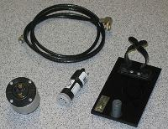
Photograph courtesy of Mike Vetterlein.
b Put the G–M tube in a stand. Adjust it so that it is pointing at the source and is about 5 cm away from it.
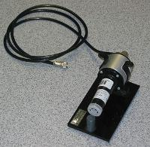
Photograph courtesy of Mike Vetterlein.
c Plug the G–M tube into the scaler (counter) and switch on.
d Start the voltage at about 200 V. Make a note of the number of counts in, say, a 15 s interval.
e Increase the voltage in steps of 25 V.
f You will find that the counts vary with voltage and then reach a plateau. A graph would look like this (you do not need to plot this):
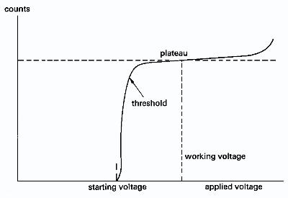
g After the threshold voltage, the count will reach a plateau. It will stay constant over a range of voltages. Set the voltage at a value of between 50 and 100 V above the threshold.
h If the clicking increases when you increase the voltage, you have moved off the plateau. Turn the voltage back down.
i Put the source back in a safe place until you carry out the demonstration.
Carrying out the demonstration
a Switch on the G–M tube counting system.
b Highlight the fact that there is a background count.
c Bring a radioactive source up to the G–M tube and draw attention to the increase in counts.
d You could measure the background count and the count with the source nearby. Do this over a period of 30 s. Draw attention to the difference.

Teaching notes
1 Discuss what is happening in the G–M tube. Point out that it is more sensitive and more stable than the spark counter.
Draw attention to the differences in count between the G–M tube and the spark counter. The G–M tube detects all of the ionisation events that take place inside it. Each one is registered.
Discuss the G–M tube as a development of the spark counter. You could say: “The wire of the spark counter is placed inside a metal shield, which acts as the other electrode, and the high-voltage supply is incorporated into the scaler The scaler does the counting of the pulses of charge delivered by the electron avalanches to the central wire. The tube is filled with a suitable gas mixture to make sure that each spark does not last too long. When the spark is quenched, the tube and the scaler are ready to count a ‘bullet’ from another radioactive atom’s ‘explosion’. As you can see and hear, the tube can react very quickly to each avalanche.”
2 The G–M tube works on the same principle as the spark counter: an ionisation between two high-voltage electrodes produces a pulse of current (an avalanche of charge) between the electrodes. The differences are that the G–M tube is sealed, it contains a low-pressure gas (usually argon with a little bromine) and it is usually part of a circuit with a scaler counter.
The scaler counter records and counts each pulse of charge.
The phenomena inside a tube are much more complicated than the simple story of ionisation producing an avalanche of electrons. Inside the tube, ultraviolet photons probably play an important part, as well as colliding electrons and ions, and the detailed picture is extremely complex.
An ionising particle will produce a pulse of charge of almost constant size. The size of the pulse does not vary with the energy or amount of ionisation produced by the ionising particle.
The number of pulses represents the number of ionising particles coming into the tube.
G–M tubes do not distinguish between one kind of particle and another, or between a more energetic particle and a less energetic one, provided that the particle enters the tube and does not pass right through (as most γη do).
This experiment was safety tested in August 2007.
Related guidance notes
- Sparks in the air
- Managing radioactive materials in schools

